**ZABBIX**

Zabbix is an open-source software tool to monitor IT infrastructure such as networks, servers, virtual machines, and cloud services.

● Zabbix collects and displays basic metrics.

● Zabbix is primarily designed for monitoring purpose.

**Zabbix basic architecture:**

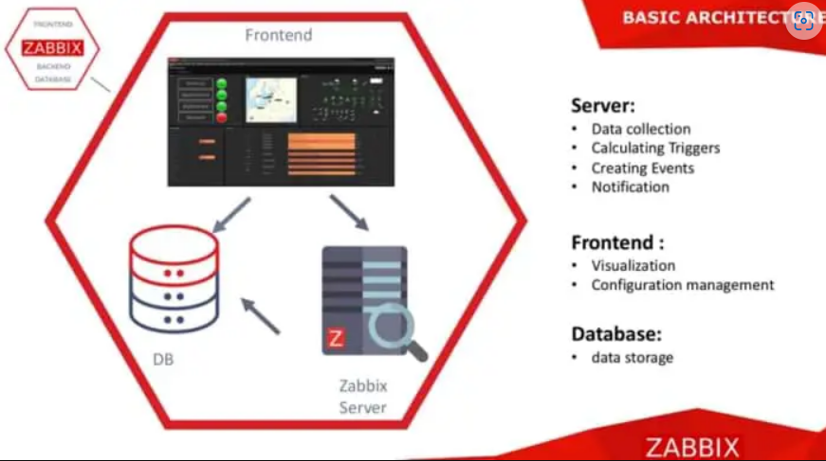

**Need For Zabbix Monitoring Tool.**

**Advantages.**

● Cost-less platform.

● Reliable features like Zabbix agent, notification and remediation module.

● Easy-to-use and robust GUI.

● Allows users to configure e-mail based alerts for virtually any event

● Excellent reporting and data visualization features based on archived data.

**Disadvantages.**

● Zabbix must include the Amazon RDS.

● Zabbix must provide more templates for rich monitoring.

**Zabbix comes with different compatibilities for downloading.**

● Below are the different ways of installing zabbix.

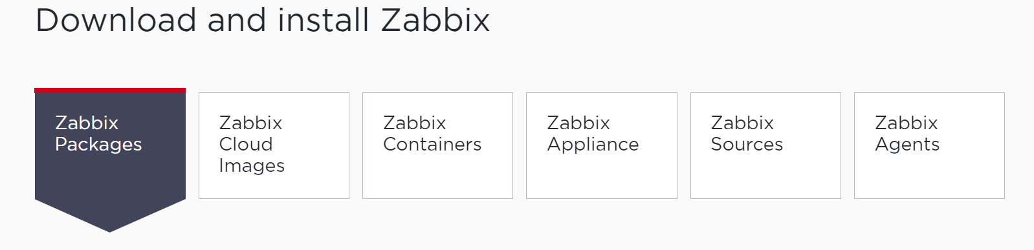

● we can download zabbix in our standalone server as package installer.

● we can download zabbix in cloud environments.

● we can download zabbix in containers and so on ..

**Requirements for running zabbix :**

● A Linux server with a recommend 2 CPU cores and 2GB of memory for a medium sized monitoring instance.

● A database software such as MySQL or PostgreSQL.

● A web-server Nginx 6.0 or later, Apache v1.3.12 or later.

● An account with full root access.

● A dedicated public IP address

We can choose the Installation based on platform.

Refer here for the official documentation

<https://www.zabbix.com/download?zabbix=6.4&os_distribution=ubuntu&os_version=22.04&components=server_frontend_agent&db=mysql&ws=nginx>

Here I have choose the required components for Ubuntu distribution.

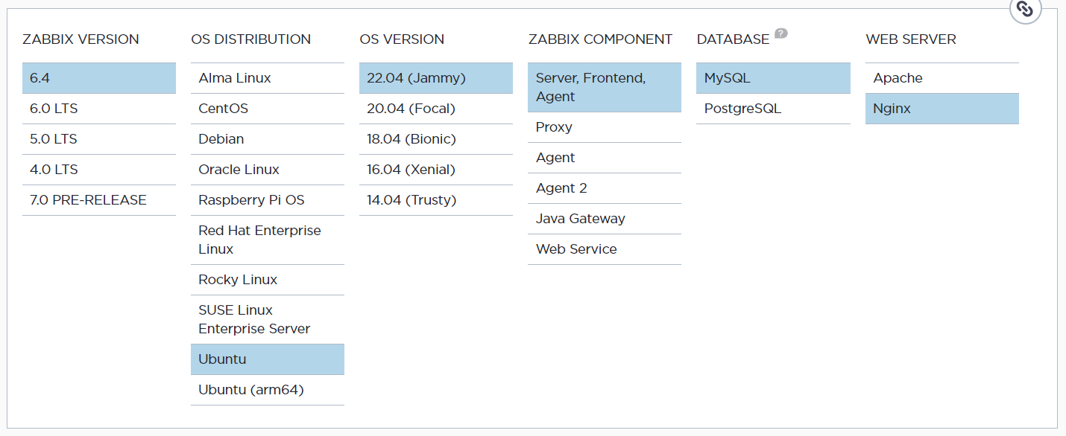

**Software requirements to install Zabbix server**

● latest zabbix version 6.4 .

● Operating System - Ubuntu 22.04

● Zabbix Component - Server, Frontend, Agent .

● Database - MySQL

● Webserver - Nginx

Now, let us install and configure Zabbix for our platform.

1. **Install zabbix repository.**

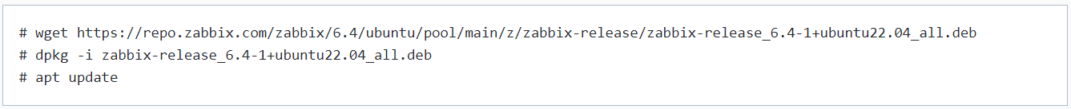

1. **Install Zabbix server, frontend, agent.**



##### **Create a database.**

Make sure we have database server up and running.

Run the following on our database host.

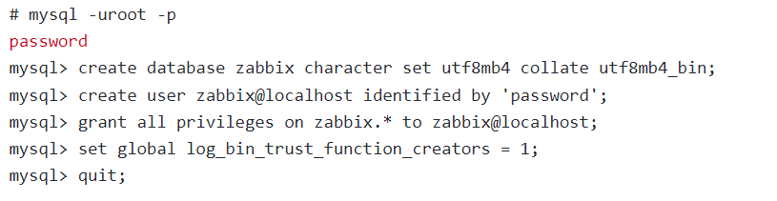

**On Zabbix server host import initial schema and data. we will be prompted to enter your newly created password.**

im

**Disable log_bin_trust_function_creators option after importing database schema.**

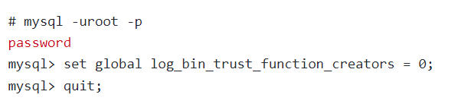

**d. Configure the database for Zabbix server**

Edit file /etc/zabbix/zabbix_server.conf



**e. Configure PHP for Zabbix frontend**

Edit file /etc/zabbix/nginx.conf uncomment and set 'listen' and 'server_name' directives.



**f. Start Zabbix server and agent processes**

Start Zabbix server and agent processes and make it start at system boot.

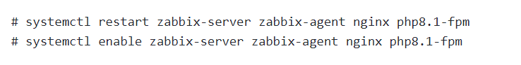

**g. Open Zabbix UI web page.**

**Open the zabbix login page by entering <public-IP/zabix>**

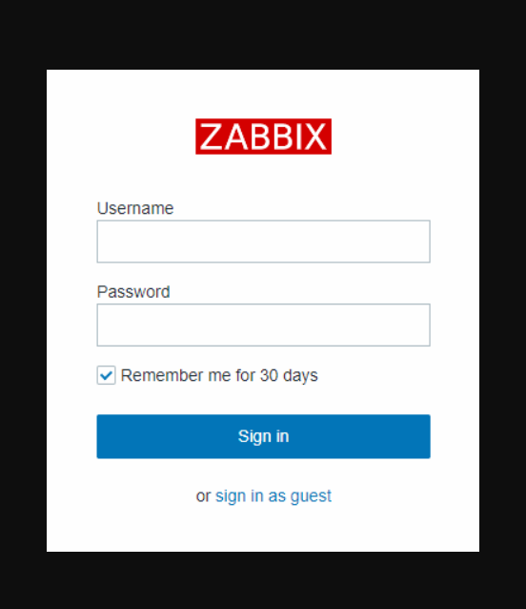

The URL for Zabbix UI when using Nginx depends on the configuration changes you should have made.

**Installing zabix on CentOS distribution:**

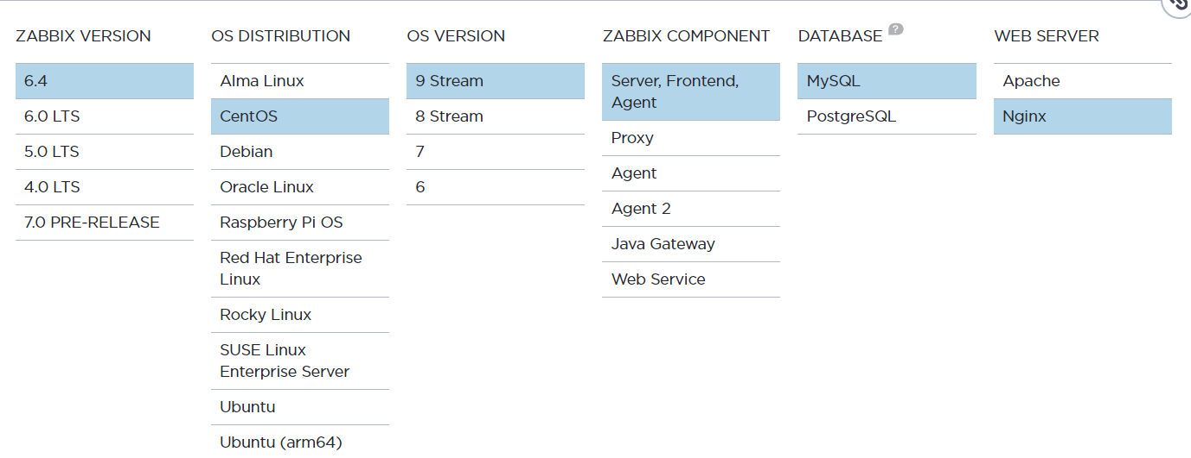

● latest zabbix version 6.4 .

● Operating System - CentOS 9stream

● Zabbix Component - Server, Frontend, Agent .

● Database - MySQL

● Webserver - Nginx

1. **Install Zabbix repository**

**Proceed with installing zabbix repository.**

# rpm -Uvh https://repo.zabbix.com/zabbix/6.4/rhel/9/x86_64/zabbix-release-6.4-1.el9.noarch.rpm

# dnf clean all

1. **Install Zabbix server, frontend, agent.**

# dnf install zabbix-server-mysql zabbix-web-mysql zabbix-nginx-conf zabbix-sql-scripts zabbix-selinux-policy zabbix-agent

1. **Create initial database.**

Make sure you have database server up and running.

Run the following on your database host.

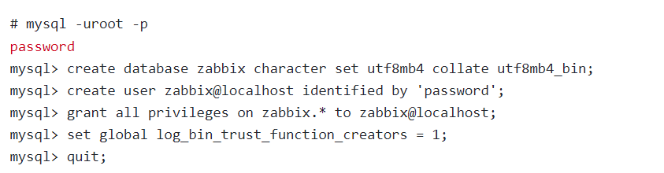

On Zabbix server host import initial schema and data. You will be prompted to enter your newly created password.

cent imp

Disable log_bin_trust_function_creators option after importing database schema.

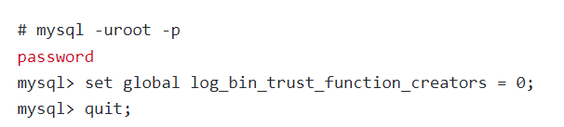

D. **Configure the database for Zabbix server**

Edit file /etc/zabbix/zabbix_server.conf

cent ch

E **.Configure PHP for Zabbix frontend**

Edit file /etc/nginx/conf.d/zabbix.conf uncomment and set 'listen' and 'server_name' directives.

# listen 8080;

# server_name example.com;

1. **Start Zabbix server and agent processes**

Start Zabbix server and agent processes and make it start at system boot.

# systemctl restart zabbix-server zabbix-agent nginx php-fpm

# systemctl enable zabbix-server zabbix-agent nginx php-fpm

1. **Open Zabbix UI web page**

**Open the zabbix login page by entering <public-IP/zabix>**

